TASK #01:

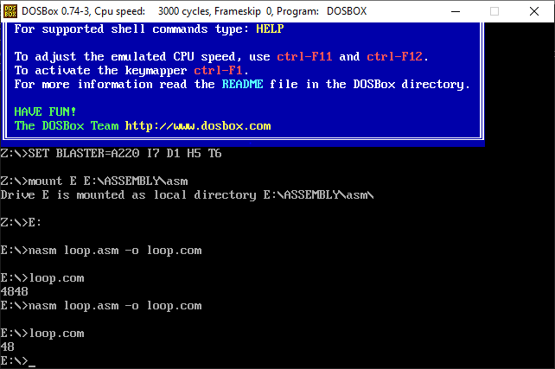ORG 100H

MOV AX, 8

MOV BX, 6

MUL BX

print:

PUSH AX

MOV BX, 10

XOR CX,CX

MOV DX,0

.REPEAT_DIVISION_AND_STORE_IN_STACK

XOR DX, DX

DIV BX

PUSH DX

INC CX

CMP AX, 0

JNZ .REPEAT_DIVISION_AND_STORE_IN_STACK

.PRINT_DIVISION_AND_STORE_IN_STACK

POP DX

ADD DL, '0'

MOV AH, 02H

INT 21H

LOOP .PRINT_DIVISION_AND_STORE_IN_STACK

POP AX

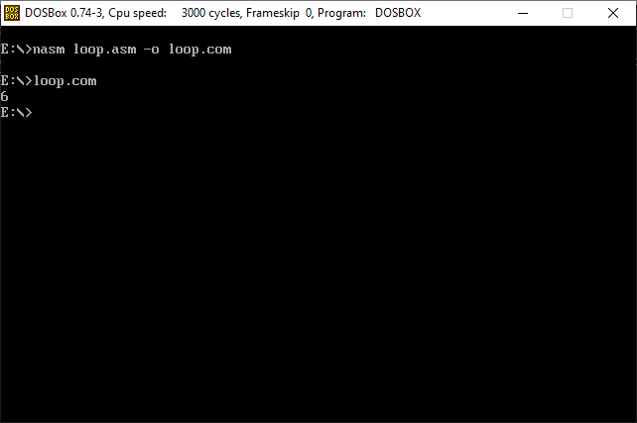ret

TASK #02:

ORG 100H

MOV AX, 36

MOV BX, 6

DIV BX

print:

PUSH AX

MOV BX, 10

XOR CX,CX

MOV DX,0

.REPEAT_DIVISION_AND_STORE_IN_STACK

XOR DX, DX

DIV BX

PUSH DX

INC CX

CMP AX, 0

JNZ .REPEAT_DIVISION_AND_STORE_IN_STACK

.PRINT_DIVISION_AND_STORE_IN_STACK

POP DX

ADD DL, '0'

MOV AH, 02H

INT 21H

LOOP .PRINT_DIVISION_AND_STORE_IN_STACK

POP AX

ret

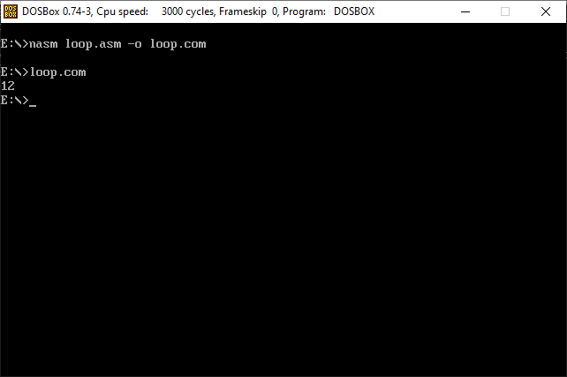TASK #03:

ORG 100H

MOV DX, 0

MOV AX, 7

MOV BX, 3

ADD AX, BX

MOV BX, 5

MUL BX

MOV BX, 4

DIV BX

print:

PUSH AX

MOV BX, 10

XOR CX,CX

MOV DX,0

.REPEAT_DIVISION_AND_STORE_IN_STACK

XOR DX, DX

DIV BX

PUSH DX

INC CX

CMP AX, 0

JNZ .REPEAT_DIVISION_AND_STORE_IN_STACK

.PRINT_DIVISION_AND_STORE_IN_STACK

POP DX

ADD DL, '0'

MOV AH, 02H

INT 21H

LOOP .PRINT_DIVISION_AND_STORE_IN_STACK

POP AX

ret